

Engineering Fundamentals
Edison Lascano PhD
NRC: 28434

02 Walkthrough

Team Members
Santórum Sandoval Thais Yetsalem
Toapanta Orejuela Adrian Michael
Vargas Pérez César Alexander
Walkthrough

Roles
Author: Santórum Sandoval Thais Yetsalem
Reviewer: Toapanta Orejuela Adrian Michael
Scribe: Toapanta Orejuela Adrian Michael
Moderator: Vargas Pérez César Alexander
Date of Analysis: October 26, 2023

Executive Summary:
A review of a recent patient registration entry has identified critical failures in the system's input validation logic. The system accepted blatantly invalid data in multiple required fields, compromising data integrity and reliability.
Detailed Error Analysis:
- Error in Field: "Nombre Completo" (Full Name)
  - Input Received: 123123
  - Issue: The field accepted numerical input.
  - Required Validation: This field should be validated to accept only alphabetic characters, spaces, and permitted punctuation (e.g., hyphens, apostrophes). It must reject any numerical digits.

- Error in Field: "Genero" (Gender)
  - Input Received: 12312
  - Issue: The field accepted numerical input.
  - Required Validation: This field should be restricted to letters only. Ideally, it should use a predefined set of options (e.g., Male, Female, Other) from a dropdown menu to prevent any free-text errors.

- Error in Field: "Telefono" (Telephone)
  - Input Received: asdhvbajshdvajhsdd
  - Issue: The field accepted alphabetical characters and is an incorrect length. It failed both data type and format checks.
  - Required Validation: This field must be strictly numerical and must be validated to contain exactly 10 digits.
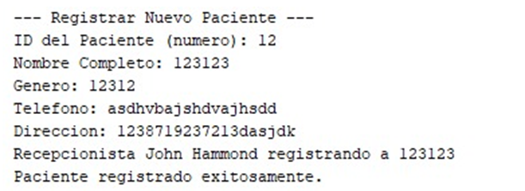
Impact:
The presence of these errors means the database contains corrupted records. This compromises data integrity, reduces system reliability, and can lead to operational inefficiencies, such as the inability to contact patients.
Recommendations:
It is recommended to implement robust server-side validation for all form fields to ensure data quality, regardless of what is sent from the front-end. The validation rules must enforce correct data types and formats before any information is saved.

